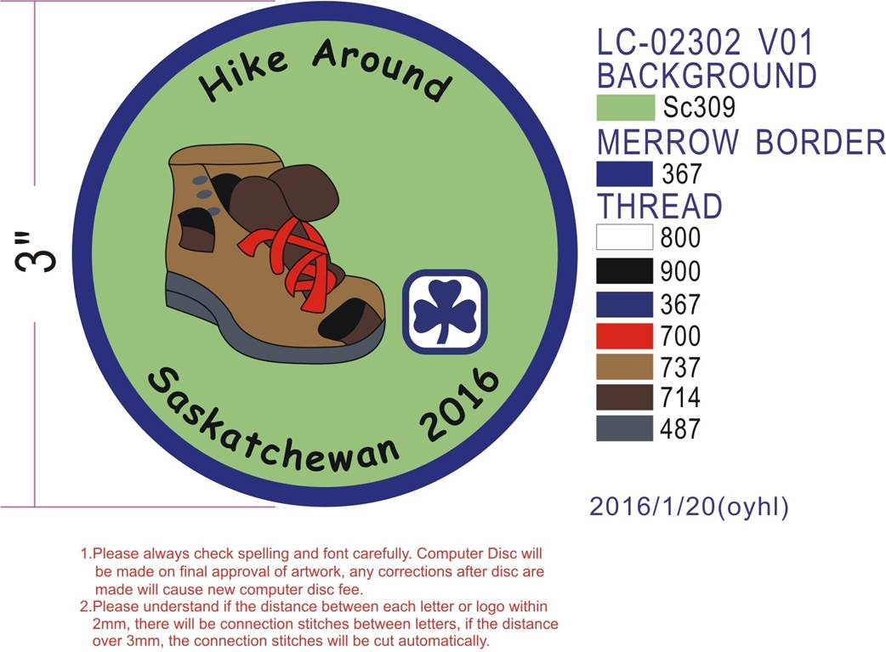

HIKE AROUND SASKATCHEWAN Crest Request Form

Remember to take photos of your hiking event and send them to: [publicrelations@girlguides.sk.ca](mailto:publicrelations@girlguides.sk.ca) or [provincial@girlguides.sk.ca](mailto:provincial@girlguides.sk.ca).

Unit Participating: ___________________________________ Number Participants: ___________

District: ______________________________________ Area: ____________________________­­­­

Hike Date: ________________________ Location of Hike: _______________________________

Mailing address for crests: __________________________________________________

______ Crests @ $2 each = $ _________ Amount Enclosed: ________________

Optional: For grant purposes please self-identify if you are: €€ First Nations €€ Metis €€Inuit or €€ € an immigrant

Girl Guides of Canada-Guides du Canada, Saskatchewan Council

200-1530 Broadway Avenue, Regina, SK S4P 1E2

**The 2016 crests are now available**.