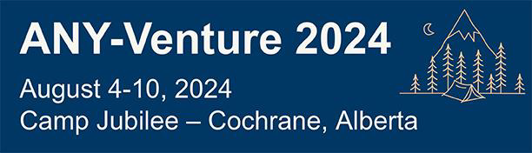

2024 Provincially Sponsored Trip to ANY-Venture Interprovincial Camp Fact Sheet
Where: Camp Jubilee – Cochrane, Alberta
When: August 4 -10, 2024 with an extension of 3 days in Calgary before or after the camp (10 days total)
Who: 8 youth registered in GGC born between January 1, 2006, and August 1, 2012
2 Guiders

Trip Summary:
Have you wanted to travel to Western Canada and meet other youth from across Canada? Now is your chance! Alberta Council is hosting an Interprovincial Camp to reignite your love of Guiding and adventure in the shadows of the Rocky Mountains. You will attend a weeklong camp that includes STEM, arts, active activities, movies under the stars, campfires, swimming, a mid-week fun day and adventure out trip options of caving, horseback riding, white water rafting and more! All meals at camp will be catered. The activities for the additional 3 days in Calgary before or after your camp will be up to your trip patrol to decide on.

Requirements:
- Be able to tent camp for 7 days
- Have GGC Swim test completed before camp
- Ability to participate in active activities
- Be away from your family for 10 days

Trip Cost: Approximately $4,100 per person Financial support from NB/PEI Provincial Council:
Youth – 1/3rd of trip cost up to a maximum of $1,000
Guider – 100% of trip cost
** Financial support for girl members is also available from your Area

Application deadline- January 31, 2023

